|  |
| --- |
| Course Code: **CCCN 221**  Course Name: Computer Architecture  **Quiz # 2** |

Convert the following below High Level Languages to Assembly Language (MIPS)



Assume that, **f**, **g**, **h**, **i**, **j, k** are in **$s0**, **$s1**, **$s2**, **$s3**, **$s4, $s5**, respectively, and base address for array **B** is in **$s7**.



**Code 1:**

if (i==j)

f = g+h;  
else

f = g-h;

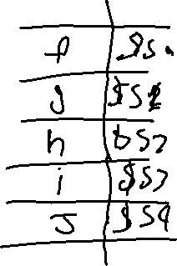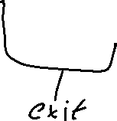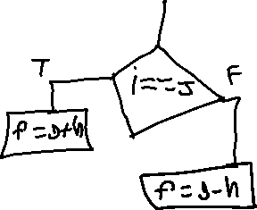

**Code 2:**

i = 0;

while (B[i] == k) i += 1;

